Request Create User from Jave To Keyloak

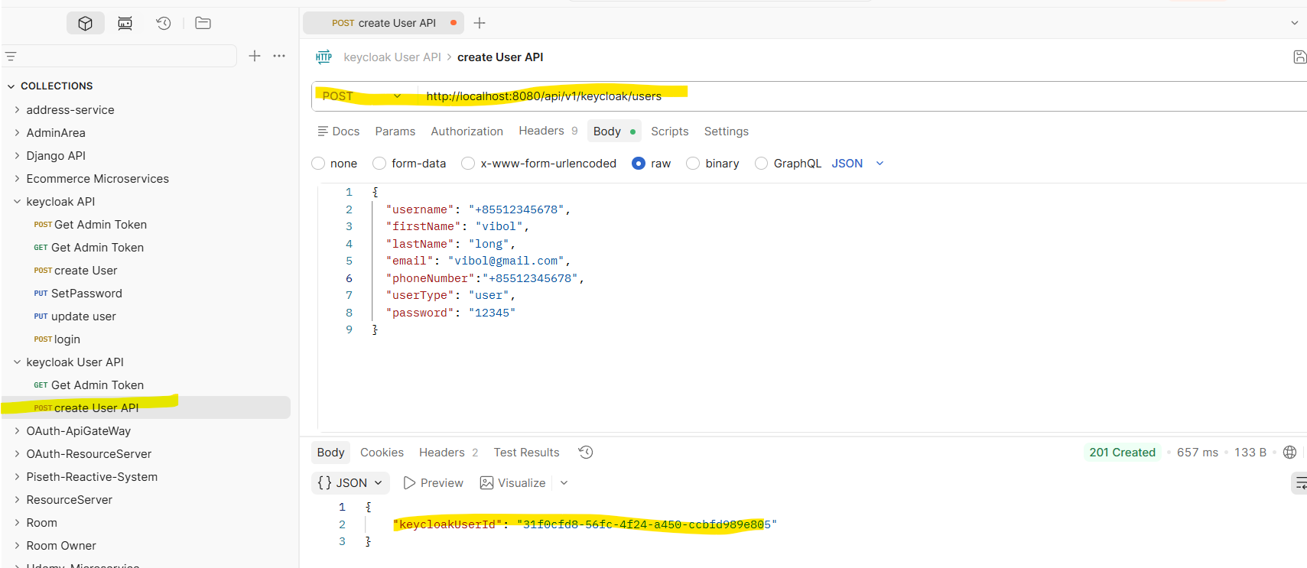

We want the respond: id from keycloak

- We start from Interface
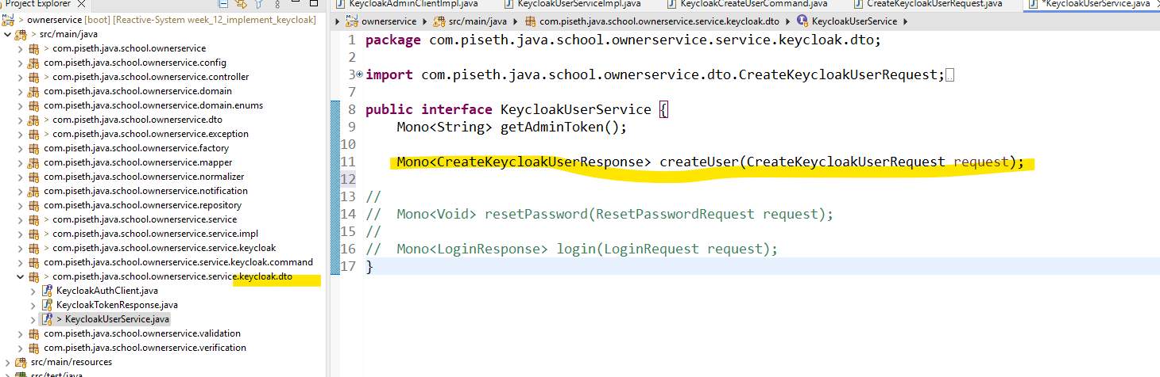

- Create KeycloakUserServiceImpl

ដំបូងយើងត្រូវធ្វើការ Call api នឹងសិនតាម Webclient

